ASSIGNMENT NO 1

***QUESTION NO 1***

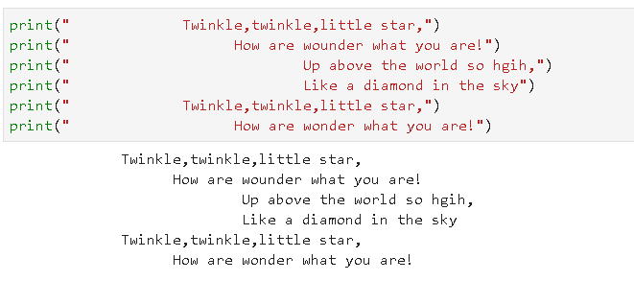

***QUESTION NO 2***

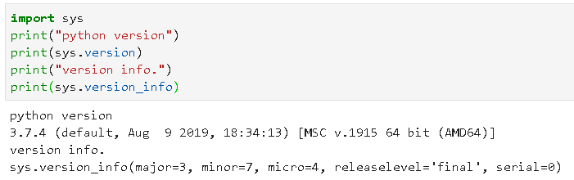

***QUESTION NO 3***

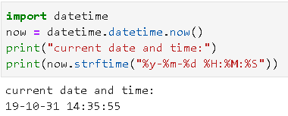

***QUESTION NO 4***

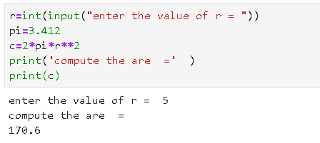

***QUESTION NO 5***

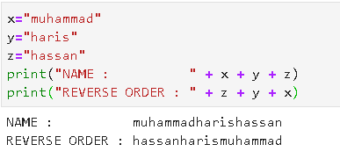

***QUESTION NO 6***

